(Answers are on last page)
I have neither given nor
received unauthorized
aid on this exam.

NAME ______________________ Signature _____________________

EXAM II
ITOM 3306
Dr. Allen (100 points) Spring, 2005

Multiple Choice and Short Answer: Each question is worth 5 points. Circle the best answer or fill in the blank for each problem.

1. In a linear programming problem, a constraint with a positive slack value
a. will have a positive shadow price.
b. will have a negative shadow price.
c. will have a shadow price of zero.
d. has no restrictions for its shadow price.

2. Which of the following statements is NOT true concerning linear programming problems?
a. A feasible solution satisfies all constraints.
b. An infeasible solution violates all constraints.
c. An optimal solution satisfies all constraints.
d. A feasible solution point does not have to lie on the boundary of the feasible region.

3. Suppose a linear programming problem with a Maximize objective function is solved using Excel. The “shadow price” on the Excel sensitivity report for a ≤ constraint tells what?
a. The most you would be willing to pay for an additional unit of that resource.
b. The least you would be willing to pay for an additional unit of that resource.
c. The cost of that resource
d. None of these
Consider the following linear programming problem which has been formulated and solved (using Excel) to answer questions #4-10. The Excel spreadsheet, Answer Report, and Sensitivity Report are included on the following pages.

A client of an investment firm has $10,000 available for investment. He has instructed that his m9oney be invested in three stocks so that no more than $5000 is invested in any one stock, but at least $1000 is invested in each stock He has further instructed the firm to use its current data and invest in a manner that maximizes his expected overall gain during a one-year period.

The stocks, current price per share, and the firm’s projected stock price a year from now are summarized below.

Stock | Current Price | Projected Price 1 Year Hence
James Industries | $25 | $35
QM Inc. | $50 | $60
Delicious Candy Co. | $100 | $125

Formulation:
Let X1 = number of shares of James Industries to purchase
Let X2 = number of shares of QM Inc. to purchase, and
Let X3 = number of shares of Delicious Candy Co. to purchase

Maximize Z = $10 X1 + $10 X2 + $25 X3

Subject to:
($ available) 25 X1 + 50 X2 + 100 X3 ≤ 10,000
(Max $ James Industries) 25 X1 ≤ 5,000
(Max $ QM Inc.) 50 X2 ≤ 5,000
(Max $ Delicious Candy Co.) 100 X3 ≤ 5,000
(Min $ James Industries) 25 X1 ≥ 1,000
(Min $ QM Inc.) 50 X2 ≥ 1,000
(Min $ Delicious Candy Co.) 100 X3 ≥ 1,000
(Non-negativity) X1 ≥ 0 X2 ≥ 0 X31 ≥ 0
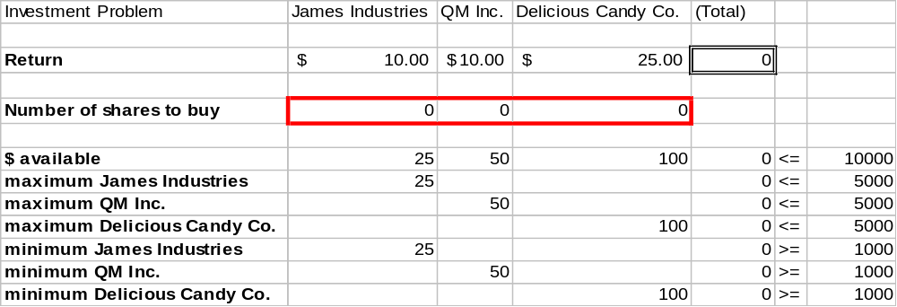
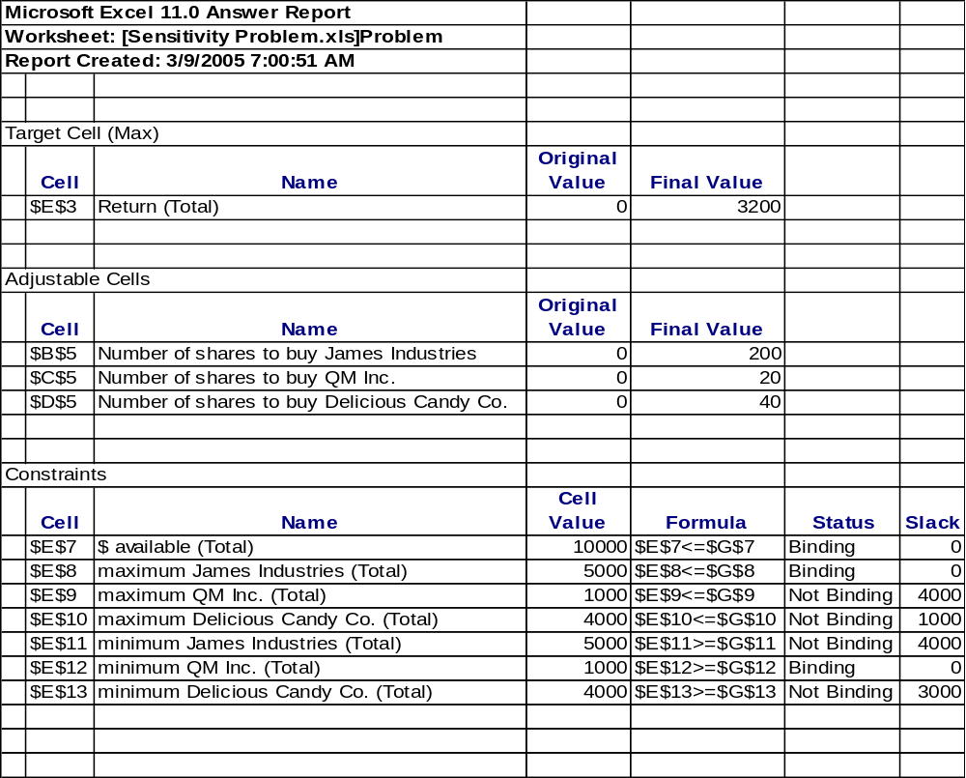
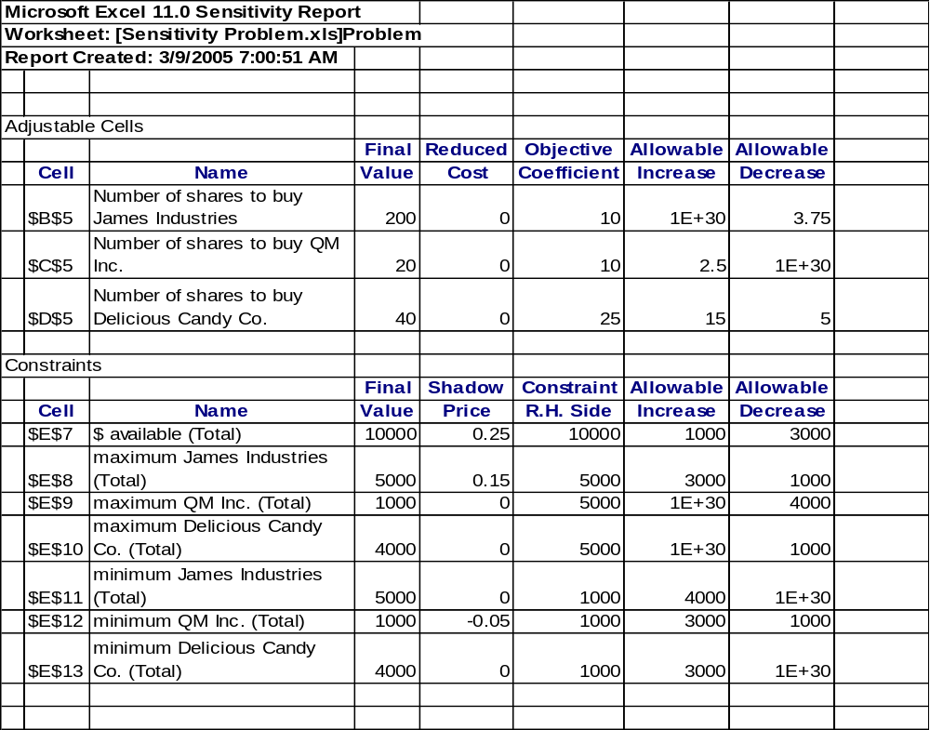
4. What is the optimal number of shares of Delicious Candy Co. to purchase?
a. 200
b. 40
c. 20
d. none of the above

5. What is the optimal expected gain?
a. $3000
b. $4000
c. $3200
d. none of the above

6. If the client had an additional $1000 to invest how much higher would the expected overall one-year gain be?

___________________________________________________

7. If the client increased the allowed maximum investment amount to $6000 for just one stock, which one should it be?

___________________________________________________

8. Based on your answer to question 7, by how much would the objective function (expected gain) increase?

___________________________________________________

9. If the expected return on shares of Delicious Candy Co. became $35 per share, would you buy more shares of Delicious Candy Co. stock? If so, how many more?

____________________________________________________

10. What value would Excel place in cell G5 of the spreadsheet if it contained the following formula? (Note that “Investment Problem” appears in cell A1)

=sumproduct(B7:B9,D7:D9)

___________________________________________________

11. (30 points) Consider the following linear programming problem, and the associated graph. Notice that the first three constraint lines have been drawn on the graph.

MIN Z = 5 X + 2 Y
S.T. X + Y ≤ 8
2 X + 5 Y ≥ 10
4 X - 6 Y ≥ 12
-4 X + 2 Y ≤ 8
X, Y ≥ 0
Y

X

- Draw the fourth constraint line on the graph.

- Shade the feasible region.

- Draw a dashed line to indicate the slope of the objective function.

- Circle the optimal point.
- What is the optimal solution? X* = _______ Y* = _______

- If the objective function is changed to Maximize Z = 10 X + Y, what is the optimal solution? X* = _______ Y* = _______

12. (20 points) Formulate the following linear programming problem. (Note: You do not need to solve the problem. Just formulate it!)

Management for Café Breakfast and More requires information on the total number of employees it will be staffing to operate its new restaurant located across the street from a major university. The minimum requirements for personnel have been broken down into 4-hour periods as follows.

Time period | Minimum # employees
7 a.m. – 11 a.m. | 12
11 a.m. – 3 p.m. | 20
3 p.m. – 7 p.m. | 18
7 p.m. – 11 p.m. | 22
11 p.m. – 3 a.m. | 20
3 a.m. – 7 a.m. | 10

Staffing is done by hiring personnel for 8-hour shifts. Obviously management would like to satisfy the requirements with the fewest number of people possible. (BIG HINT: Define six decision variables as follows: Let X1 = # of personnel to begin an 8-hour shift at 7 a.m. Let X2 = # of personnel to begin an 8-hour shift at 11 a.m., and so on.)

Answers:
- c
- b
- a
- b
- c
- $250
- James Industries
- $150
- No
- 2500
- Optimal solution is (3 ¾, ½ )
Optimal solution to (f) is (8,0)
- Decision variables:
Let X1 = # of personnel to begin an 8-hour shift at 7 a.m.
Let X2 = # of personnel to begin an 8-hour shift at 11 a.m.
Let X3 = # of personnel to begin an 8-hour shift at 3 p.m.
Let X4 = # of personnel to begin an 8-hour shift at 7 p.m.
Let X5 = # of personnel to begin an 8-hour shift at 11 p.m.
Let X6 = # of personnel to begin an 8-hour shift at 3 a.m.

Objective:
Minimize Z = X1 + X2 + X3 + X4 + X5 + X6

Constraints:
X1 + X2 ≥ 20
X2 + X3 ≥ 18
X3 + X4 ≥ 22
X4 + X5 ≥ 20
X5 + X6 ≥ 10
X1 + X6 ≥ 12

X1 ≥ 0, X2 ≥ 0, X3 ≥ 0, X4 ≥ 0, X5 ≥ 0, X6 ≥ 0

